**SUBTRACTION USING 8086 PROCESSOR**

**Expt:no:34**

**AIM:** To write an assembly language to implement subtraction using 8086 processor.

**ALGORITHM:**

1. Load the first 16-bit number (num1) into the AX register.

2. Load the second 16-bit number (num2) into the BX register.

3. Use the SUB instruction to subtract the value in the BX register from the value in the AX register.

4. Check the Carry Flag (CF) to see if there was a borrow during the subtraction.

5. If the Carry Flag is set (CF = 1), it means that the result is negative.

6. You can use the JC (Jump if Carry) instruction to handle the negative result accordingly.

7. If the Carry Flag is not set (CF = 0), it means that the result is positive or zero.

8. You can proceed with further operations or store the result as needed.

**PROGRAM:**

MOV AL, 06H

MOV BL, 0AH

SUB BL, AL

MOV CX,00008H

PRINT: MOV AH,02H

MOV DL,030H

TEST BL,080H

JZ ZERO

MOV DL,031H

ZERO: INT 021H

SHL BL,1

LOOP PRINT

MOV DL,062H

INT 021H

MOV AH,00H

INT 016H

RET

NOP

NOP

NOP

RET

**OUTPUT:**

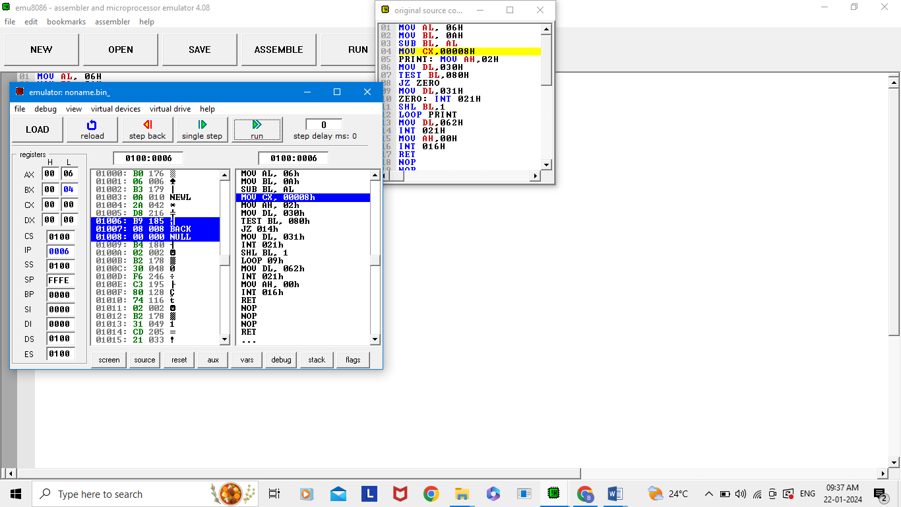

**RESULT:** Thus the program implemented successfully using 8086 processor.